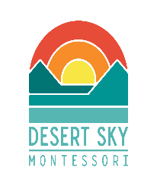
Desert Sky Montessori
Board Meeting Agenda
October 19th, 2022 at 6:15 pm

CALL TO ORDER
OPEN FORUM
BUSINESS
A. Reports and Minutes
a. Approve September Board Meeting Minutes
b. Head of School Report
c. Financial/Treasurer Report
B. Facilities
C. Board President Updates

ACTION ITEMS

ADJOURNMENT

Executive Session
Vision
Students empowered to share their unique gifts with the world
Our Mission
Desert Sky Montessori provides all children with an environment for joyful exploration that fosters self-discovery and a life-long love of learning

